University of Leeds

Finance
Leeds
LS2 9JT
TRAVEL AND SUBSISTENCE EXPENSES FORM - UK CLAIMS ONLY
(Overseas travel to be claimed on the separate form - OSTS prefix)
Please refer to the University’s financial policies and guidelines for clarification www.leeds.ac.uk/finance/policies/expenses
Department (or address)
Name
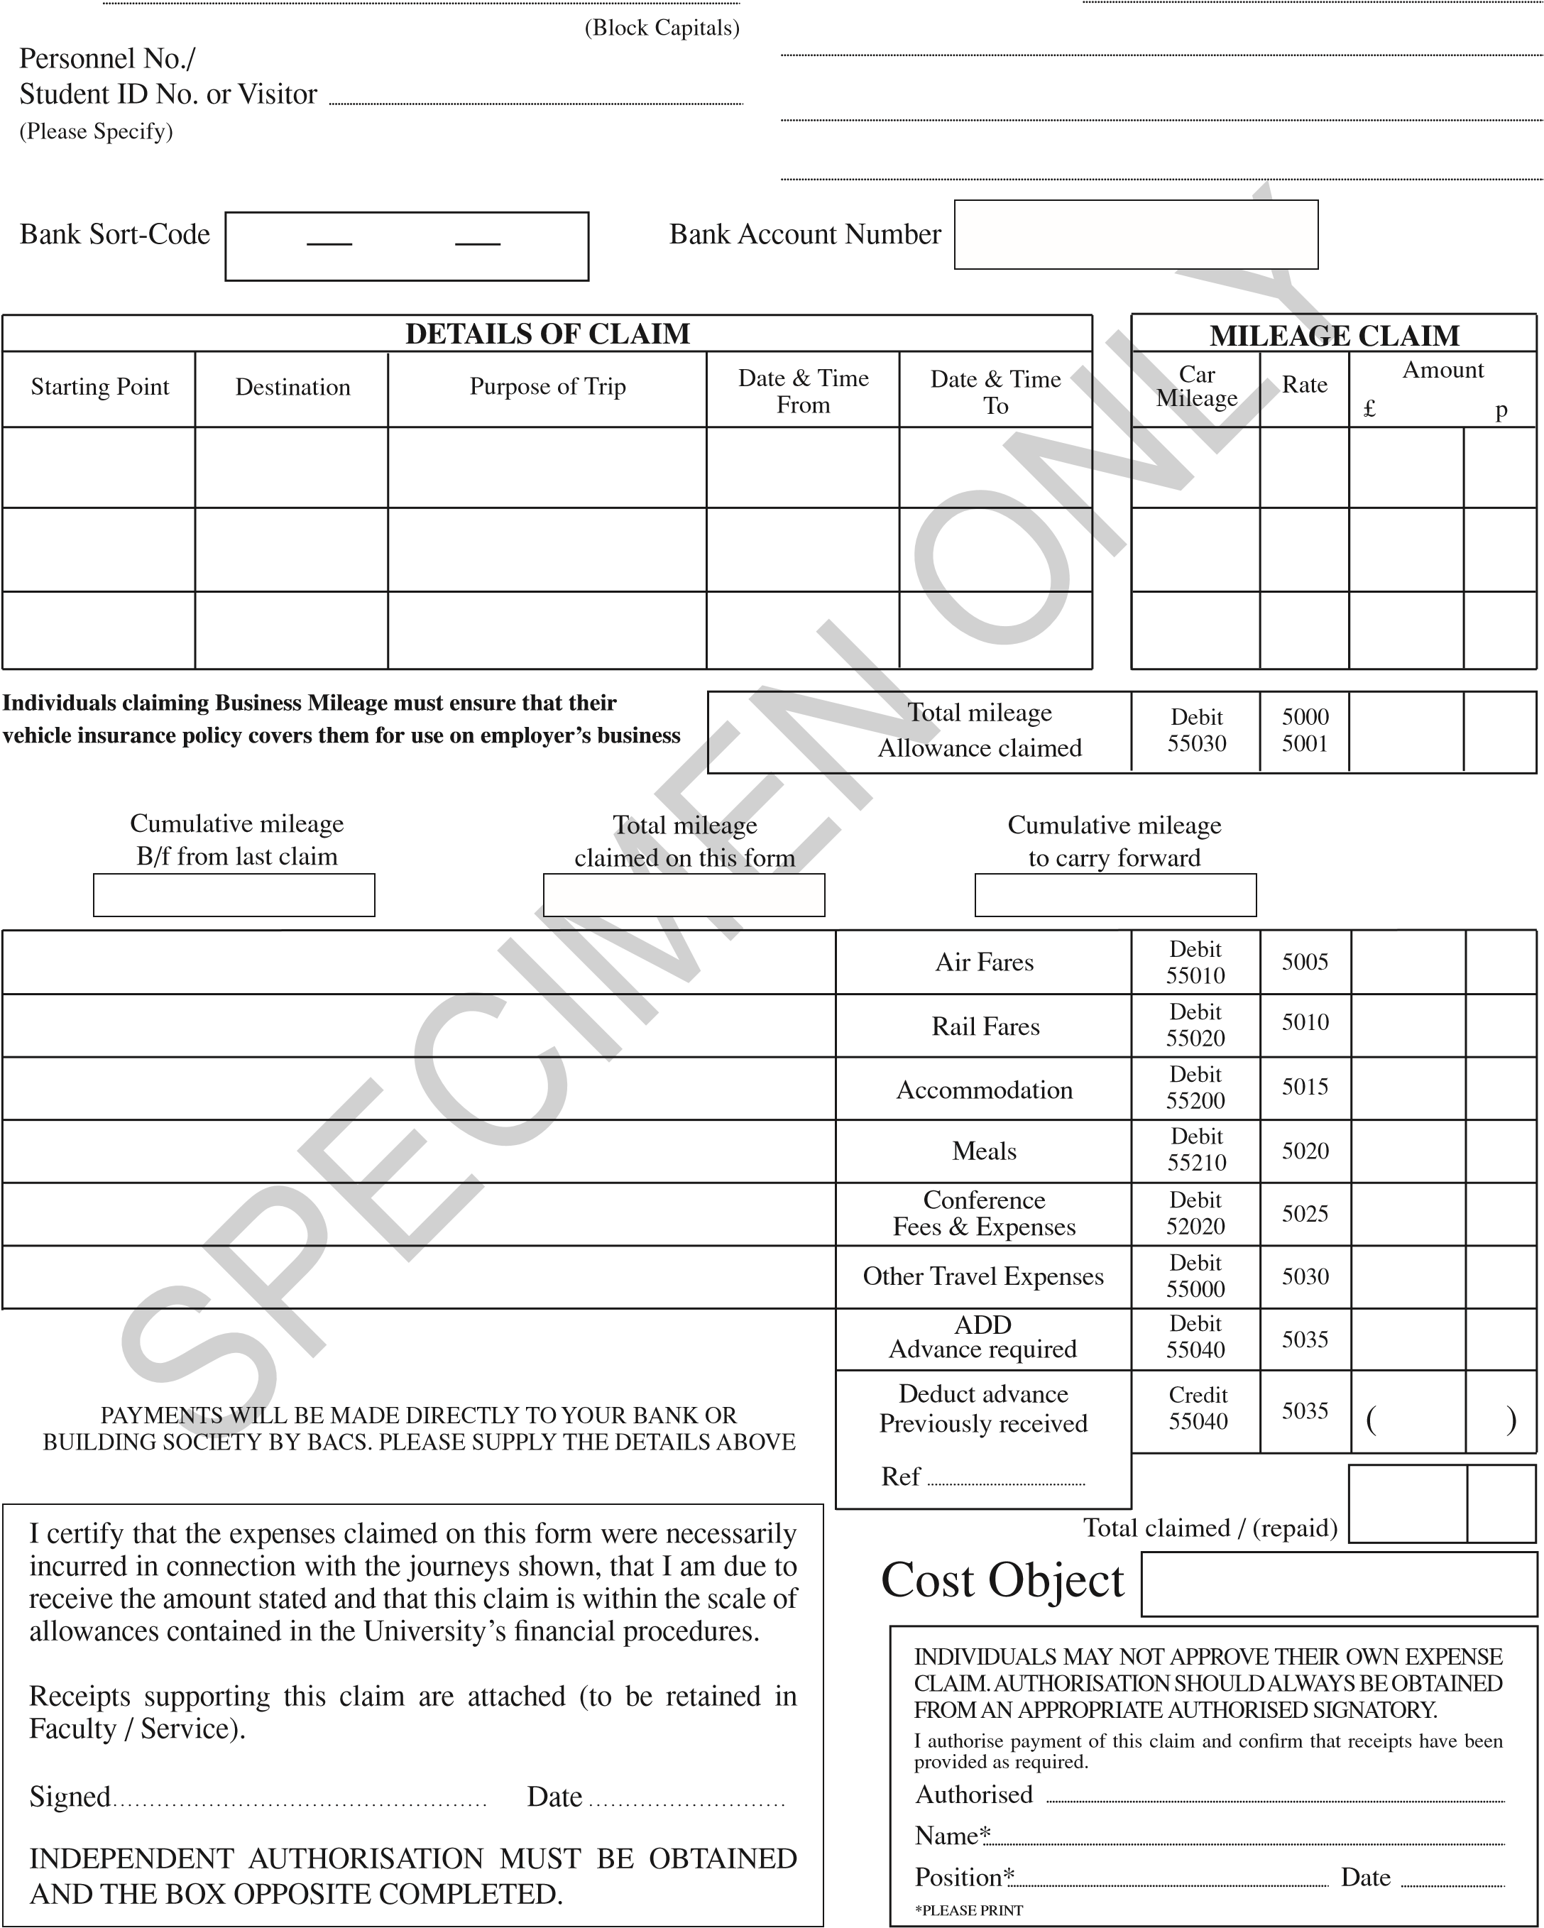
YOUR NAME LIDA, Level 11 Worsley,
12345 University of Leeds, Clarendon Way, LS2 9NL

12 34 56 123456

Leeds Liverpool Data conference 1/9/19 2/9/19 x

x
Open return from Leeds- Liverpool 19 60
Hotel X one night 80 0
Evening meal & breakfast
21 0
300 0 0
Data conference ticket

x

420 60
Leave blank

Your signature x/x/x Leave blank

